Appendix I

Programming a Blank SD card with a Yocto Linux Image
To prepare the Galileo board for use, installation of the Yocto image to the supplied blank micro-SD card is necessary.
Note: If you have attended one of our Roadshows, you can skip this step, as you have been given a micro-SD card already prepared.
- Download the latest image from http://iotdk.intel.com/images/iot-devkit-latest-mmcblkp0.direct.bz2
NOTE: Each image has a corresponding md5sum, stored in a file with the same name but with the .md5sum suffix. This md5sum is used to check if the file has been downloaded without any errors. The Win32 Disk Imager tool shown below can calculate an MD5 checksum.
- Using 7zip extract the downloaded image file iot-devkit-latest-mmcblkp0.direct.bz2 on your Windows system.
NOTE: 7zip is a tool that supports an extended file path, which is required for this file,Winzip and built in Zip extractors in Windows Explorer will likely not work.
- Insert the micro-SD card in the appropriate card slot on your Windows development system. Check the disk identity using Windows Explorer, especially of you have any other portable devices, eg a USB disk inserted.
- Download the Win32DiskImager utility and install it as an Administrator. After successful installation, run the Win32Diskmager as an Administrator.
- Ensure that you have selected the device drive that contains your inserted micro-SD card for writing.
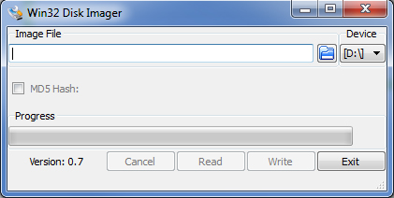
- Then browse to the unzipped/extracted image by clicking on the browse button. Be sure to select *.* file option to find your *.direct image file and click the Open button
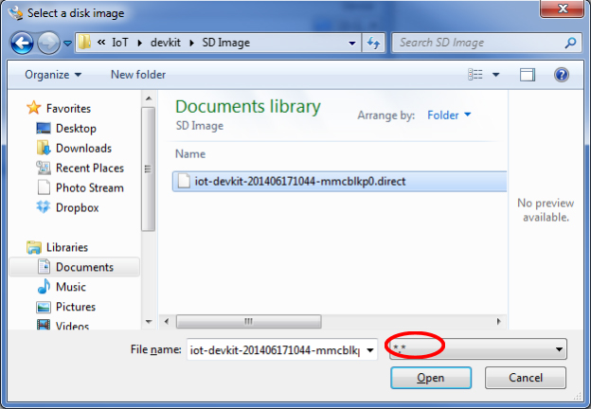
- Again ensure that the Device drive you want to write to is correct and then click the Write button to start the operation.
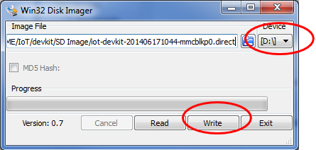
- Finally after completing the write process, select the Exit button and close the application. Now your micro-SD card is ready to be used with Intel Galileo board.

https://software.intel.com/en-us/node/530353

